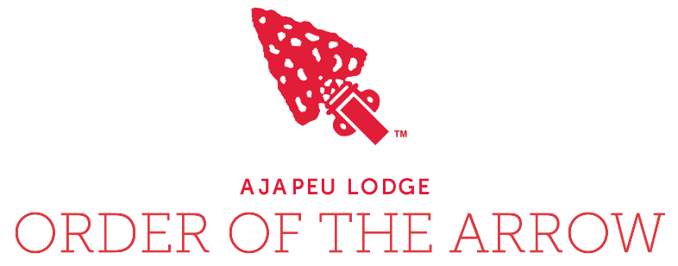
Table of Contents
Troop OA Representative & Advisor Handbook
2019 Version

Lodge Letter to Troop OA Representative 2

Job Descriptions
Troop OA Representative Job Description 3
Troop OA Representative Advisor Job Description 4

OA Completion Schedule of Forms 5

Lodge and Chapter Communication
Troop OA Representative & Advisor Contact Info 6
Ajapeu Lodge Communication Structure 7

OA Troop Visit/Election
Back Dates for OA Troop Visit/Election 8
OA Troop Visit/Election Request Form 9
OA Youth Election Report 10
Greetings Brother!

Ajapeu Lodge is excited that you are willing to serve your Troop, Chapter, and Lodge! Serving as the primary form of communication between your Troop, Chapter, and Lodge, you have the most important job within Ajapeu Lodge.

Scouts in your troop that are eligible to join the Order of the Arrow depend on you to schedule a Troop OA Visit and Election.
Ordeal Candidates within in your Troop depend on you to walk them through the process of becoming a member of the Order of the Arrow.
New Ordeal members will depend on you to show them how to seal their Brotherhood.
Fellow Arrowmen within your Troop depend on you to inform them on upcoming Order of the Arrow events.
Your Scoutmaster will depend on you to promote camping within your Troop.
The Chapter Chief will depend on you to encourage others to attend Chapter meetings.
The Lodge Chief will depend on you to recognize the achievements of those within the Order of the Arrow at your Troop’s Court of Honor.

We are relying on you to complete your role as a Troop OA Representative!

Feel free to contact us with any questions at ajapeu351@gmail.com.

Yours in Brotherhood,
The Brothers of Ajapeu Lodge

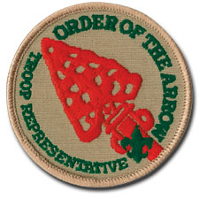
OA Troop Representative
Duties:
- Attends unit, Chapter, and Lodge meetings regularly as a youth representative of the Troop and of the Order.
- Serves as a two-way communication link between the unit and the Chapter.
- Arranges with the Chapter to conduct an annual Order of the Arrow Troop Visit (Elections & Camp/High Adventure Promotion) for the Troop at a time approved by the Patrol Leaders Council.
- As requested by the SPL, participates in Troop Court of Honors by recognizing high adventure participation of Troop members, induction of new OA members, changes in OA honors of unit members, leadership of unit members, and other appropriate activities.
- Coordinates the Ordeal Induction process for newly elected candidates by ensuring they know the time, date and location of the Ordeal. Provide information of what to bring to the Ordeal. Offer assistance to the Lodge in the Ordeal process.
- Assists current Ordeal members in the Troop in sealing their membership by becoming Brotherhood members. Ensure they know the time, date and location of Brotherhood opportunities. Offer assistance to the Lodge in the Brotherhood process.
- Lead at least one unit service project for the community or charter partner during the year.
- Assists the unit (as appropriate) as a trainer of leadership and outdoor skills.
- In all cases, advocates environmental stewardship and Leave No Trace camping.
- Sets a good example by: wearing the Scout uniform correctly, showing Scout spirit, and living by the Scout Oath, the Scout law and the OA Obligation.
Qualifications:
- Under 18 years old
- Appointed by SPL with Scoutmaster approval
- OA Member in good standing
Reports To:
- SPL
- Chapter Chief
Term:
- Serves for a 12 month period
- Appointed at least 60 days before the unit OA election to facilitate election procedures and fulfill follow-up duties.
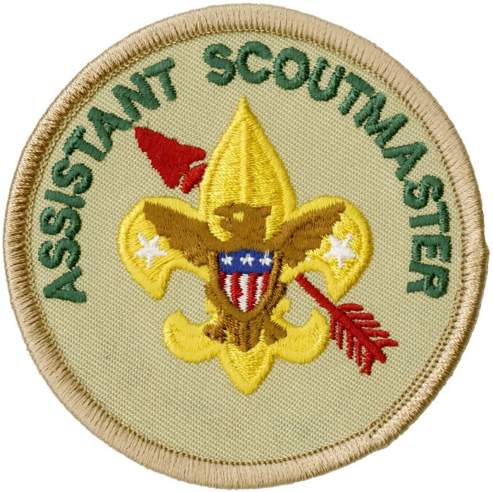
OA Troop Representative Adviser

The adviser to the Troop Representative assists the youth representative so that he might succeed in his role as the communication and programmatic link between the unit and the Lodge or Chapter. The adviser helps to include the Order of the Arrow ideals and activities in the program of the Troop. Be setting a good example, the adviser enhances the image of the Order as a service arm to the unit.
Duties:
- Supports the youth he or she advises, helping him to fully understand the needs of the unit and the elements of the Lodge and Chapter structure that are responsible for support to the unit.
- Promotes the incorporation of OA ideals into the advancement program of the unit, in unit leader conferences, boards of review, and courts of honor. Promotes recognition of members who have completed their Ordeal, achieved Brotherhood, or been inducted into Vigil Honor membership within the unit.
- Attends Lodge and Chapter meetings with the youth he or she advises.
- Ensures that the OA Representative and Arrowmen in the Troop have the necessary transportation.
- Helps the Lodge, Chapter, or Extended Elangomat in insuring that messages and documents regarding the achievement of Brotherhood reach Ordeal members in the Troop and works with the OA Representative to assess their impact.
- Assists the OA Representative in providing feedback to the Lodge or Chapter the reaction of the unit and its OA members to the success of the OA programs which affect the unit, including Ordeals, unit elections, call-outs, camp promotion visits, meetings and service projects.
- Sets a good example
- Enthusiastically wears the Scout uniform correctly.
- Lives by the Scout Oath, Scout Law and OA Obligation
- Shows Scout spirit
Qualifications:
- A unit assistant leader or committee member at least 21 years old
- Appointed by the Scoutmaster with the approval of the unit committee chairman
- OA member in good standing
Reports To:
- Troop Scoutmaster
- Chapter Advisor
OA Completion Schedule of Forms

The following form is to help ensure that all forms are submitted on time. These forms are important for the communication and scheduling event for your Troop/our Order.

FORM |  | SUMBITTED TO | WHEN TO BE COMPLETED | DATE DONE
1 | Troop OA Rep & Advisor Contact Information | Chapter Chief & Advisor  And  Lodge Chief & Advisor | When you become Troop OA Rep/Advisor
2 | OA Troop Visit/Election Backdate | Troop OA Advisor & Troop Scoutmaster | Start:  Oct. – Nov.
3 | OA Troop Visit/Election Request | Chapter Chief & Advisor | Oct. – Nov.
4 | OA Youth Election Report | Richard Kent or Address on the form | Before May 1st

Troop OA Rep & Advisor Contact Form

This form should be filled out by the Troop OA Representative, Advisor, and Scoutmaster. Please double check the information provided so we can ensure that you and your scouts do not miss out on any opportunities.
Please send to ajapeu351@gmail.com upon completion
Troop OA Rep
Name: |  | Date:
Address:
City: |  | Zipcode:
Email (Youth):
Email (Parent):
Home Phone: | Cell Phone:
Term of Office (Dates): | Ordeal / Brotherhood / Vigil (Circle One)
Scouting Experience:
OA Experience:

Troop OA Rep Advisor
Name: |  | Date:
Address:
City: |  | Zipcode:
Email:
Home Phone: | Cell Phone:
Term of Office (Dates): | Ordeal / Brotherhood / Vigil (Circle One)
Scouting Experience:
OA Experience:

Scoutmaster
Name: | Email:
District: | Unit Number:

Ajapeu Lodge Communication Structure
Troop #3
Troop #2
Troop #1
Troop OA Rep
Troop OA Rep
Troop OA Rep
Lodge Officers
Chapter Officers
Lodge Executive Council
Chapter Meeting
Troop Meeting
OA Troop Visit/Election Backdated

TASK |  | COORDINATOR(S) | DAYS BEFORE ELECTION | DATE TO DO
1 | Set date of Troop/Team election, in coordination with the Chapter | OA Rep & Chapter Chief | -60
2 | Begin promotion of the election to the Troop/Team | OA Rep | -45
3 | Follow up with Chapter, ensure that an election team will be present | OA Rep & Chapter Chief | -30
4 | Call Patrol Leaders, make sure that all Troop/Team members are present | OA Rep & PLC | -7
5 | Re-follow up with Chapter, ensure that an election team will be on hand | OA Rep & Chapter Chief | -7
6 | Hold Election | Unit Elections Team | 0
7 | Send completed unit election form to Lodge | OA Rep & Scoutmaster | +2
8 | Ensure that all candidates in the unit are present for the call-out ceremony | OA Rep
9 | Ensure that all candidates in the unit are registered for the Ordeal | OA Rep & Chapter Chief
10 | Ensure that Troop/Team has Elangomats at Ordeal for candidates | OA Rep & Chapter Chief
11 | Provide transportation to Ordeal for the candidates and Elangomats | OA Rep Advisor
12 | Recognize new OA members at unit Court of Honor | OA Rep

Order of the Arrow Troop Visit/Election Request
Please fill in all of the blanks and print clearly.
Chapter/District:
Town:

Unit:
Location of Meeting:

Meeting Time:
Where is the Troop attending Summer Camp:
1st Date:
2nd Date:
Please list the Troop’s availability in order of preference (Dates must be between 1/1st & 4/30st)
3rd Date:
OA Troop Rep:
Phone Number:
Email:

Scoutmaster:
Phone Number:
Email:
Do you have any youth eligible for the OA? Y / N
1.
2.
3.
4.
5.
6.
7.
8.
9.
10.
If so, list their names:
Eligibility Requirements:
- Registered BSA Member
- Under 21 Years Old
- Rank of First Class or Higher
- 15 nights of camping with the BSA. Must include one, but no more than one, long-term camp consisting of at least five consecutive nights of overnight camping.
- Have Scoutmaster’s approval

Troop OA Rep Signature
____________________________
Troop OA Rep Advisor Signature
____________________________
Scoutmaster Signature
____________________________

Special Directions:
Please return form with re-charter packet or mail to:
Green Mountain Council
P.O. Box 557 Waterbury, VT 05676
ATTN: OA ELECTIONS

FOR CHAPTER USE ONLY
Date Scheduled:
With Election or Without Election
(Circle One)

OA Youth Election Report
Unit Number:
Number of Registered Active Youth:
District:
Number of Youth Present:
Date of Election:
NOTE: At least half of the registered active unit members must be present to hold an election.
Fill in the names and ranks of eligible youth before election
Results of election YES = elected and NO = not elected
Name | Rank | Elected | Name | Rank | Elected
Number Eligible: | Number of Votes Required for Election:
Number Elected: | Number of Ballots:
I certify that the above youth members are eligible & I approve them as nominees for election.
Unit Leader’s Signature _______________________________________________________
Election Team Signatures _______________________ ___________________________
(at least one signature must be a youth’s)

E-Mail or mail election report immediately following completed election but before May 1st to:
Richard Kent: richarda.kent@myfairpoint.net or mail to: 1478 State Highway 132, Sharon, VT 05065
Following Must Be Filled Out Completely As Shown On Unit Charter
(Print CLEARLY, use second page for additional candidates):
(THIS FORM WILL NOT BE ACCEPTED BY THE LODGE IF NOT FILLED OUT COMPLETELY)
Name: |  |  |  |  |  | DOB:
Address: |  | City: |  |  | State: |  | Zipcode:
Home: | Cell: |  |  | BSA ID#:
Email(Youth): |  |  | Email(Parent):

Name: |  |  |  |  |  | DOB:
Address: |  | City: |  |  | State: |  | Zipcode:
Home: | Cell: |  |  | BSA ID#:
Email(Youth): |  |  | Email(Parent):

Name: |  |  |  |  |  | DOB:
Address: |  | City: |  |  | State: |  | Zipcode:
Home: | Cell: |  |  | BSA ID#:
Email(Youth): |  |  | Email(Parent):

Name: |  |  |  |  |  | DOB:
Address: |  | City: |  |  | State: |  | Zipcode:
Home: | Cell: |  |  | BSA ID#:
Email(Youth): |  |  | Email(Parent):

Name: |  |  |  |  |  | DOB:
Address: |  | City: |  |  | State: |  | Zipcode:
Home: | Cell: |  |  | BSA ID#:
Email(Youth): |  |  | Email(Parent):

Name: |  |  |  |  |  | DOB:
Address: |  | City: |  |  | State: |  | Zipcode:
Home: | Cell: |  |  | BSA ID#:
Email(Youth): |  |  | Email(Parent):

Name: |  |  |  |  |  | DOB:
Address: |  | City: |  |  | State: |  | Zipcode:
Home: | Cell: |  |  | BSA ID#:
Email(Youth): |  |  | Email(Parent):

Name: |  |  |  |  |  | DOB:
Address: |  | City: |  |  | State: |  | Zipcode:
Home: | Cell: |  |  | BSA ID#:
Email(Youth): |  |  | Email(Parent):

Name: |  |  |  |  |  | DOB:
Address: |  | City: |  |  | State: |  | Zipcode:
Home: | Cell: |  |  | BSA ID#:
Email(Youth): |  |  | Email(Parent):

Name: |  |  |  |  |  | DOB:
Address: |  | City: |  |  | State: |  | Zipcode:
Home: | Cell: |  |  | BSA ID#:
Email(Youth): |  |  | Email(Parent):

